Managerial Decision for firms with Market Power
Name of Author:
Institution:
Date:

Research Topic: The Analysis of Managerial Decision for firms with Market Power- Case of Tesla in the Electric Car Industry

Executive Summary
xxx

Introduction
It is usually every management’s aspiration that their company acquires significant market power to drive up its profitability. However, acquiring market power is quite elusive and often available to firms which operate within industries with notably strong barrier to entry by other players. Many times, pioneer firms with specialized technologies, exclusive copyrights/patents and having large economies of scale enjoy trading in markets with enormous market power (Lábaj, et al., 2018). Ideally, in the long run, firms with dominant market power generate above average economic profits due to demand inelasticity (Nowlan, 2018). From economic point of view, the decision making in such monopolistic but competitive markets takes a unique approach. This research paper deeply explores how management decisions are made within firms with market power, within the scope of profit maximization and reduction of the costs. This paper takes the form of a systematic lit review involving an in-depth review of literature as well as theoretical frameworks within this area of study. Finally, an empirical framework modeling will be undertaken followed by an in-depth data analysis to make sense out of the data. Adequate graphic details will be given and thoroughly explained to support key arguments.

Literature Review

Defining Market Power
Firstly, market power is often associated by the fraction of the share of the market that a firm serves within a definite period of time. In putting it differently, market power refers to the ability of a firm to increase the prices of its goods and/or services without suffering loss of its sales (Thomas, and Maurice, 2016). Having market power allows a firm to raise its prices to a level above the average costs and accrue economic profit, when the cost and demand conditions allow it. From an economic perspective, any firm that experiences a downward sloping demand curve implies that the firm has market power. Worth noting, having market power does not always mean that the firm has endless possibilities to output on the market. For instance, in a qualitative survey of a history of market power in the US, Loecker & Eeckhout (2017) found that availability of market power has impacts on allocation.
Ideally, firms with market power, whose prices are above marginal cost produce less in outputs compared to those outside monopolistic markets. Also important to outline, having market power can in itself be a deterrent to better growth and adaptability. Nowlan’s (2018) assessment of the failures in monopoles found that failure to accurately read market trends was a key reason to business failure since most firms get comfortable in conditions that they operate within and fail to be adaptable. There is a need to grow, reinvent and adapt to take opportunities in the market. In a typical example, IBM had greater focus on developing mainframe computers that it failed to venture in personal computers. Even when it eventually did, it used ideas from other firms. It general reluctance to venture into PCs contributed to getting stuck in mainframe computers which became obsolete as other market players went into the more prosperous PC industry (Nowlan, 2018).
  - Decision Making in Monopolistic Markets
    - Demand Elasticity
Before exploring how managerial decisions are made in companies with market power, it is essential to understand how demand play out. Usually in monopolistic markets, the measure of market power rests in the elasticity of demand. Ideally in competitive markets, there is perfect levels of demand elasticity. It means that when demand is more elastic, there is greater percentage decrease in the sales which a company records as the prices increase. In monopolistic markets, the demand elasticity is lower, meaning that there is smaller decrease in sales as prices rise (Cowan, 2018). As an economic standpoint, the extent to which a company amasses market power is inversely proportional to the elasticity of demand. Since such firms with more market power experiences less elasticity of demand, they have more freedom to alter their prices without adverse effects on their sales revenues. This is also informed by lower numbers or complete absence of close subtitles that the consumers can rely on as alternatives (Thomas, and Maurice, 2016). Also, essential to note while the Lerner index (P-MC/P) is zero in perfect competition, the index rises in the monopolistic marker due to greater market power (Thomas, and Maurice, 2016). As it in the case of Tesla, the unavailability of similar companies who have commercialized the production and sale of electric cars gives Tesla more market power. If it were to adjust the price of say, its Model X car by 5 percent, the availability of subtitles results in lesser variations to the company’s sales revenues, all other factors held constant.
Lerner Index= (P-MC)/P
Where, P is the price and MC, the Marginal Cost

    - Case of Tesla & Barriers to Entry
For this analysis, Tesla is an example of a firm that enjoys immense market power within the auto making industry. It is a Silicon Valley start-up enterprise that has pioneered the making of zero-emission automobiles (Stringham et al., 2015). Tesla has been for more than two decades ventured in the development of electric cars while other automakers still design diesel engine cars (Debord, 2020). Within the spirit of going green and developing ecofriendly cars, Tesla is a true market leader and pioneer in the field. Its status, relative to other car makers, can be described as a mini-monopoly still its differentiated products ultimately compete with other products from other companies such as Toyota, BMW, Land rover and Tata among many others. Recvlohe’s (2019) assessment of Telsa was that it neither produces fancy cars for wealthy consumers nor offers any unique experience as compared to other automobile products. It is pioneer firm that sought to develop cars that run fully on electricity which makes it a first in this field. It therefore positions itself as an aggressively innovative firm which embeds high technology capabilities to ensure their cars run on electricity as opposed to the diesel engines. In essence, Tesla sells almost every car that it produces on the market which implies operation on a monopolistic market (Thomas, and Maine, 2019: Debord, 2020). The following illustration shows the timeline of Tesla and some of the car models it has developed over time.
Figure 1: Telsa Timeline- (Up to 2017)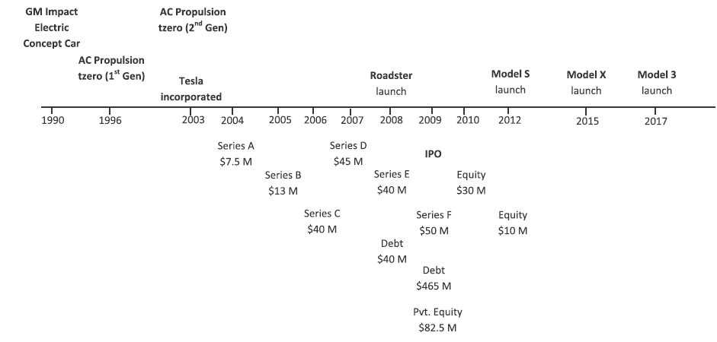
Source: Thomas, and Maine, (2019, p. 657)

One of the distinctive features of low elastic markets are the high numbers of barriers to entry (Rosado-Cubero, 2015). These are financial, operational or other types of difficulties that it are unfavorable to new entrants to operate in the market. For the case of electric vehicles (EV), a pioneer company like tesla operates on a new norm as opposed to conventional operations for other carmakers. While it arguable that other firms are on the verge of making a move on Tesla-like products, the monopoly of knowledge and patents makes the field less receptive to the new entrants. Tesla, in its innovative capabilities have set up unique technologies that support the making of electric cars. Stringham et al.’s (2015) assessment of the barriers to the electric automobile industry noted high set-up and operational costs, enormous economies of scale, and network effects of service lead and distribution. Tesla has made bold steps include taking over a 5.5 Million square feet GM garage at Freemont, California to be its high-technology production plant. The company has invested largely in unique technologies and patented them, including high level expertise and special infrastructure to support the making of the electric vehicles (Stringham et al., 2015). The company has also sought strategic partners such as the Lotus Elise licensed technology to deliver special equipment and technology. These and other features make Tesla as software firm as much as a hardware entity and at one time its owner Elon Musk remarked that a Telsa automobile is “a very sophisticated computer on wheels” (Stringham et al., 2015, p. 94). Therefore the uniqueness of the company to pioneer the production of EVs makes it hard to imitate and it currently enjoys a micro-monopoly in this sector.
    - Profit Maximization Decision
For a firm with market power, the market demand curve is equivalent to the firm’s demand curve. The profit maximization decisions for such a firm is attaining a production quantity where the Marginal revenue (MR) is equal to the marginal cost (MC) in the long run. In this scenario, the cost of producing one extra product should be equal to the revenue that will be earned on the product. As already identified above, a firm operating in a monopolistic market perceives demand to shift in favor of the price. Unlike in a perfect competition, as shown in the illustration below, the demand curve for a firm with market power slants downwards.

Figure 2: Demand Curve; Perfect Competition vs. Monopolistic market
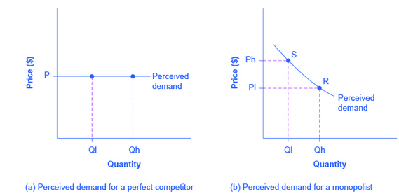
The demand curve of a monopolistic firm (which is similar to the market demand curve) implies that should it choose higher amounts of output (Qh), it charges a relatively low price (P1). On the other hand, if it desires low output levels (Q1), it charges a relatively higher price (Ph) (OpenStax, 2016). Therefore, managerial decision lies with finding a proper combination of quantity and price to yield maximum profits.

Figure 3: Profit maximization for a monopolist firm
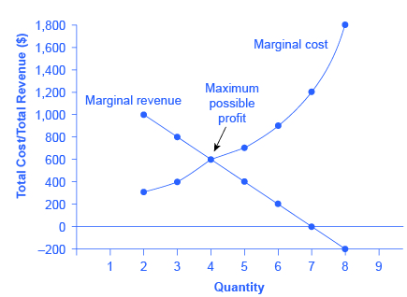
From the above illustration (3), the marginal cost is an upward sloping curve which implies that as more quantities are produced, the more marginal cost the firm incurs. Then the marginal revenue curve which slants downward indicates that the marginal revenues reduce as additional units get produced. Ideally, with higher price and lower quantity of output, maximum profits are guaranteed. As long as total revenue (TR) shields the total avoidance costs, the monopolist will produce additional unit. Importantly, the demand curve would inform the price at which the ideal output levels that will yield maximum profits (Thomas, and Maurice, 2016). This price is often higher than the long run average cost and it is where a firm will realize economic profits. If the price falls below the long run average costs, the firm will have to exit the market as shown in illustration (4) below. Ideally, only where the marginal cost equals the marginal revenues, it is where such a firm gets maximum (supernormal) profits (von Blanckenburg and Neubert, 2015).

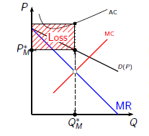  Figure 4: If P<LAC the firm makes losses | 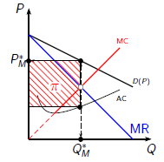  Figure 5: Firm makes profit if P>LAC

A crucial take-away for a monopolistic firm is that the goal should therefore be maximizing marginal revenues as opposed to just maximizing the profits (Mert, 2018). It is because its stability on the market is determined not by the profit maximization conditions but by the at marginal revenue maximization conditions. Mert, (2018) also affirms that if the Lerner index is viewed in term of the profit maximization condition, rather than the revenue maximization, positive Lerner index would reveal significant market power. Nevertheless, the magnitude of the index would not show the market power. For Tesla, as an innovative production firm that seeks equilibrium on the market, emphasis ought to be on conditions that would maximize its marginal revenues. Further on, in their critique, Reksula et al. (2008) identified that innovation enabled monopolistic firms expand their output levels, cut on costs and reduce their pricing. To lower both the opportunity cost and deadweight costs, innovation need to be prudent embraced so that consumers appeal more to the products produced. As entity closely aligned to innovative practices, the differential value is boosted by these innovations so that it stands out on the market. The company has mad upward improvements in innovation including developing the newer models; Model X, S and Y. More prudently the company has been ambitious enough to cut down on the prices of some of its models. Tesla downsized the price of Model 3 by $2000 to cost about $39,190 currently while models S and X saw significant price cuts of about $5,000 on each model (Beresford, 2020). The price changes are strategic moves to ensure incremental marginal revenues and thus a better grip on the market.

- Theoretical Framework
The relevant theoretical framework to explain the nature of monopolistic markets and managerial decision is the theory of monopolistic competition developed by Edward H. Chamberlin in 1933.

Section of References being used;

Beresford, C. (2020). Tesla Lowers Model S Price Further Despite Price Cuts Last Summer. CarandDriver. Retrieved on 11 November 2020 from https://www.caranddriver.com/news/a32686279/tesla-price-cuts-model-s-model-x-model-3/
Cowan, S. (2018). Regulating monopoly price discrimination. J Regul Econ 54, 1–13 Doi: 10.1007/s11149-018-9361-2
Debord, M. (2020). Tesla's cars are too expensive, and Elon Musk knows it — here's why that could be a big problem for the electric-vehicle leader. Business Insider Africa. Retrieved on 11 November 2020 from https://africa.businessinsider.com/opinion/teslas-cars-are-too-expensive-and-elon-musk-knows-it-heres-why-that-could-be-a-big/vepl7rr
Lábaj, M., Morvay, K., Silanič, P., Weiss, C., & Yontcheva, B. (2018) Market structure and competition in transition: Results from a spatial Analysis. Applied Economics, 50:15, 1694-1715, DOI: 10.1080/00036846.2017.1374535
Mert, M. (2018). What does a firm maximize? A simple explanation with regard to economic growth. International Journal of Engineering Business Management, 10, 18479790188152
Nowlan, E. (2018). X-Inefficiency in Monopolies. HON499 projects, No. 14.pp. 1-44 Retrieved on 11 November 2020 from http://digitalcommons.lasalle.edu/honors_projects/14
OpenStax, (2016). Principles of Economics. Houston: Rice University
Recvlohe, C. (2018). Tesla Is a Monopoly, We Just Don’t Know It Yet. Medium Corp. Retrieved on 11 November 2020 from https://medium.com/swlh/tesla-is-a-monopoly-we-just-dont-know-it-yet-157131037ef8
Reksulak, M., Shughart, W. F., & Tollison, R. D. (2008). Innovation and the opportunity cost of monopoly. Managerial and Decision Economics, 29(8), 619–627. Doi:10.1002/mde.1425
Rosado-Cubero, A. (2015). Barriers to entry vs. competitive strategy. Cuadernos de Estudios Empresariales, 25, 67-86 Doi:10.5209/rev_CESE.2015.v25.53633
Stringham, E. P., Miller, J. K., & Clark, J. R. (2015). Overcoming Barriers to Entry in an Established Industry: Tesla Motors. California Management Review, 57(4), 85–103. doi:10.1525/cmr.2015.57.4.85
Thomas, C., & Maurice, C. (2016). Chapter 12: Managerial Decision for firms with market power In Managerial Economics, 12th Edition. New York: McGraw Hill.
Thomas, J., and Maine, E. (2019). Market entry strategies for electric vehicle start-ups in the automotive industry – Lessons from Tesla Motors. Journal of Cleaner Production, 235, 653-663 DOI: 10.1016/j.jclepro.2019.06.284
Von Blanckenburg, K., & Neubert, M. (2015). Monopoly Profit Maximization: Success and Economic Principles. Economics Research International, Vol. 2015, Article ID 875301, 1-10 Doi:10.1155/2015/875301

